Our team focused on the forces driving sales of Hybrid and Plug-in Electric Vehicles. We were motivated by the rise in global warming and “hype” around electric vehicles, such as Tesla.

## Question 1: What do the sales of Hybrid and Electric Vehicles look like over the past few years?

We decided to perform our analysis on data from 2010 to 2017, as this was the broadest time range possible to obtain data for sales of mass-produced vehicles of both types in the U.S. Hybrid Vehicles having representation as early as 2000 with the Toyota Prius and Plug-in Electric Vehicles with cars such as the Nissan Leaf and Chevrolet Volt arriving in 2010.

From data obtained through the Department of Energy’s Transportation Energy Data Book, from 2010 to 2017, sales of Electric Vehicles increased from 300 to 195,600 vehicles per year, while sales of Hybrid Vehicles increased from 274,600 to 362,900 vehicles per year. These changes are illustrated below.

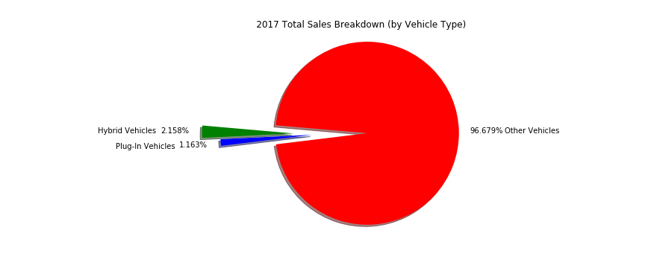

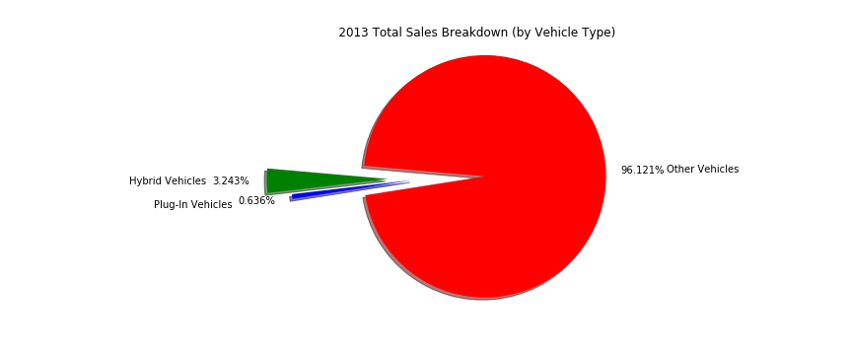

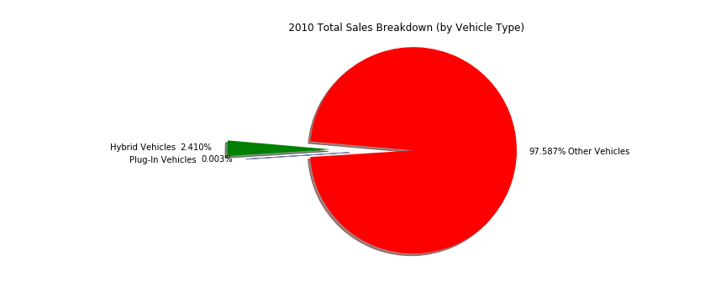

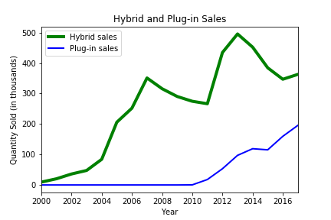Review of the charts listed above led us to question why Hybrid sales appear to fluctuate while Electric sales increase in each year given. The plot below gives a smoother depiction of this phenomenon.

Conclusion:

While sales of Hybrid and Electric Vehicles constitute a much greater percentage of the light automobile market share, sales of Electric vehicles appear to be more consistently trending positively.

Our team then chose to look at a number of internal and external market factors that could affect sales of electric and hybrid evhicles.

# Internal Market Factors

## Question 2 - How are Electric Vehicles impacting the automobile industry?

Using data from 2011 to 2016, we were able to visualize this dataset by showing trend in sales over the years by the brand. We wanted to focus solely on EVS instead of HEVS.

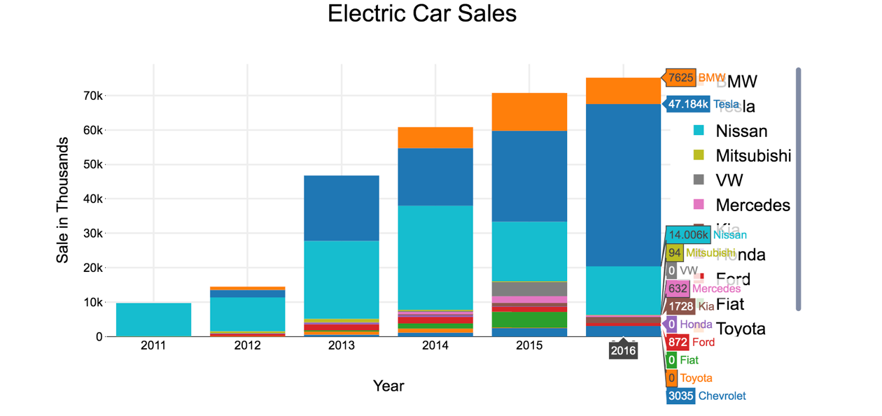

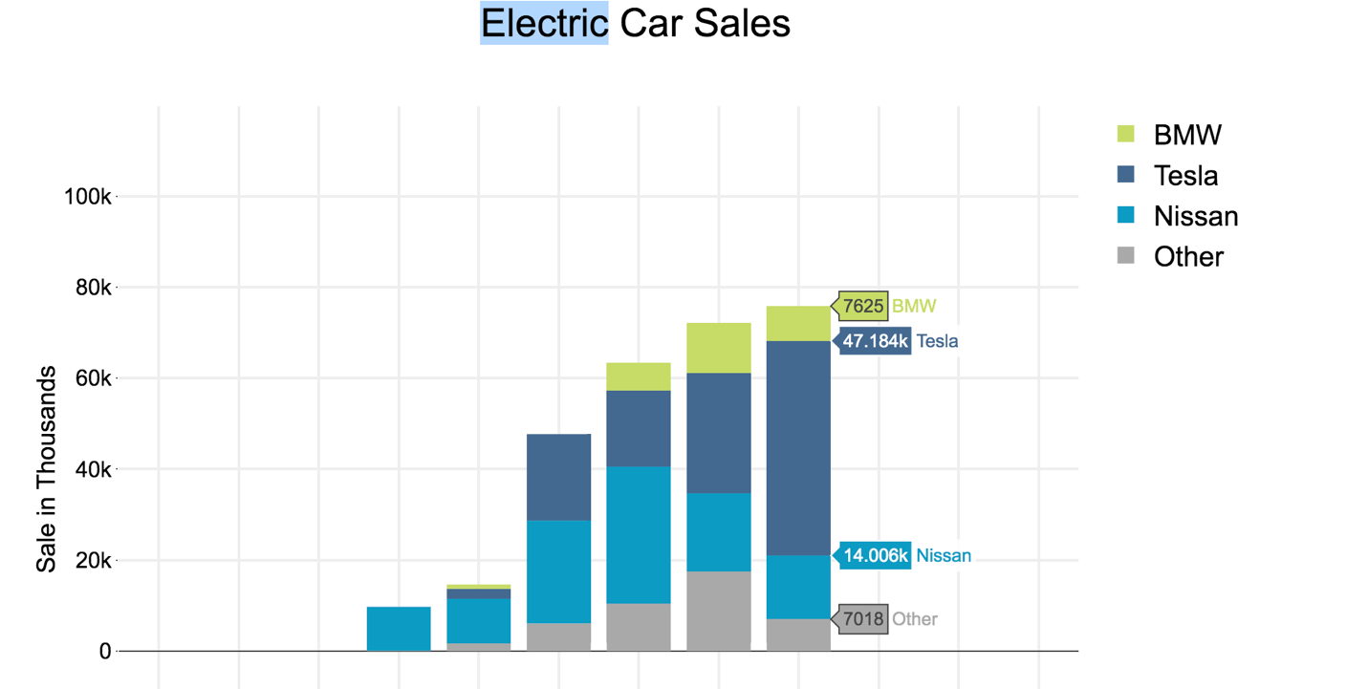

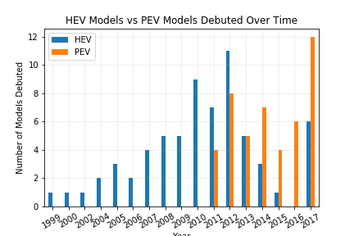

Conclusion:

There has been an overall growth of sales in the market since 2011. Tesla, BMW and Nissan seem to be the top players in EV market and have growth yearly. Nissan has shown the most consistency in EV sales since earlier debut in 2011. Tesla has shown tremendous growth nearly 20x during a 5-year span.

There is an increase in the number of brands producing PEV vehicles that increases with sales, and as sales of PEV vehicles rise, we see the introduction of luxury car makers into the market.

There is a decrease in the release of new HEV vehicles that correlates with the volatility in hybrid vehicle sales.

# External Market Factors

## Question 3 – Do gas prices have an effect on the sales of Hybrid and Electric Vehicles?

After reviewing the sales data, we saw a large fluctuation in sales of Hybrid Vehicles vs the steady uptick in sales of Electric vehicles.

After investigating U.S. gasoline prices, we obtained the following apparent relationship:

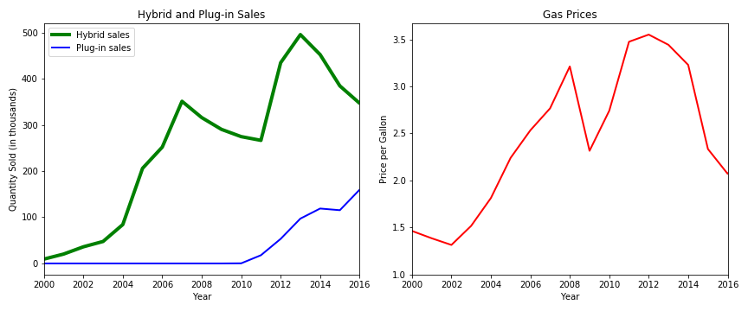

Conclusion:

While sales of Hybrid and Electric Vehicles constitute a much greater percentage of the light automobile market share, sales of Electric vehicles appear to be more consistently trending positively and appear to be impacted far less by major changes in U.S. gasoline prices.

## Question 4 – Does expanded electric charging infrastructure impact sales of PEV vehicles?

Even though the average American drives less than 50 miles a day and the average electric car battery range is 200 miles, many people still feel anxiety trusting their trip to an electric car. The media and experts have dubbed this “range anxiety”. Gas stations are abundant, but it’s a lot harder to spot a place to plug in your Tesla on a long road trip.

The National Renewable Energy Laboratory, a federal laboratory under the purview of the US Department of Energy, tracks the location and other data on Alternative Fuel Stations in the United States. They have an API available that allowed me to pull this data into a Pandas Data Frame.

Our pull was limited to electric charging stations only and the field we looked at were the opening date, latitude and longitude, state, and access type. We did not end up using the access type information in my final analysis, but if we had more time, we would want to see the spread of publicly available stations vs privately held stations.

We specifically looked at the opening date of each station and charted that over time. Our sales data for PEVs starts in 2010, when the first mass produced electric vehicles started to hit the market. We see a correlating explosion in the opening of EV charging stations. This continues and peaks in 2012, around the time when the Tesla Model S is released. There is drop and climb between 2012 and 2016, which is the year that Tesla releases the Model 3.

This could indicate a ramp up of infrastructure that proceeds the release of particularly popular PEV models. Given more time, I would attempt to chart the “enthusiasm” of the vehicles cited above using Google Trends and APIs for news sites for data on search hits and media coverage.

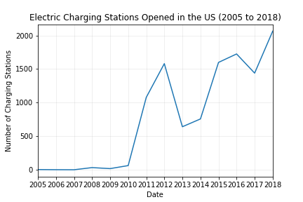

We do see an increase in the opening of charging stations, but is it enough?

Location matters. If there are ten stations in your home town, but none on the road to grandma, an electric car is still going to feel limiting.

The National Renewable Energy Laboratory released a report in September of 2017 theorizing the projected infrastructure needed to create unlimited access. The below graphic represents, in red, the range electric vehicles could travel in the US if there were charging stations on all major interstates.

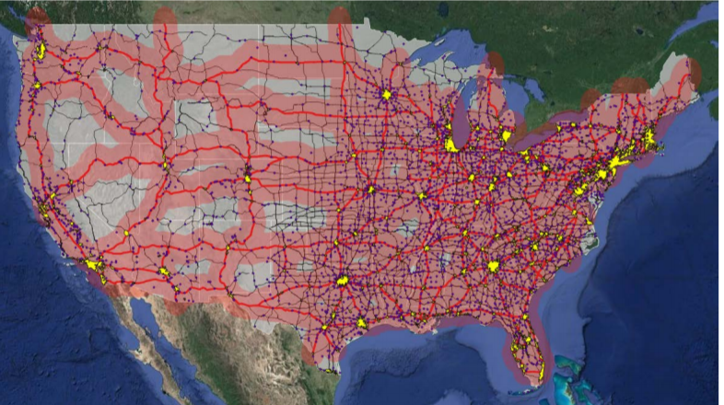

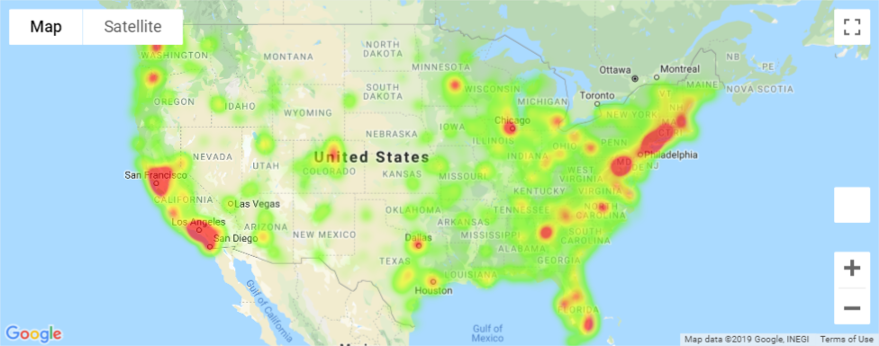Using the Google Maps API, we created a heat-layer to show the location and density of the stations currently open in the United States.

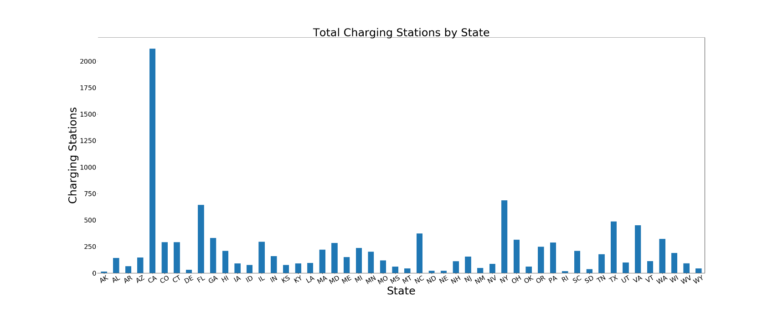

Charging stations are grouped primarily around major metropolitan areas and the coasts. A large portion of the country remains underserved.

Conclusion:

We see an increase in stations opened that does track with PEV sales. Station openings slightly lead sales and the largest jump in openings occurs in 2010 – 2011, where PEV sales begin to take off. Largest increase in stations opened track to the years that the Nissan Leaf and Chevy Volt were introduced (2010 and 2011 respectively) and peaks at the introduction of the Tesla Model S (2012) and again at the introduction of the Model 3 (2016), suggesting station openings are effected by sales and enthusiasm around new car models.

Current station density is not high enough to connect most areas of the country outside of dense urban areas and the Eastern Seaboard.

## Question 5 – Are sales of electric vehicles effected by incentives (such as tax breaks)?

Both at the state and federal level, there are different incentives and laws designed to steer the population towards greener transportation options. We wanted to track those incentives and see if they made an noticeable impact on electric and hybrid vehicle sales.

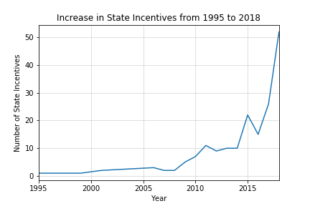The National Renewable Energy Laboratory also provides an API for all Tax Incentives and Laws for alternative fuel vehicles. Our pull was limited to incentives for electric, plug in electric, and hybrid technologies. The incentive also had to include a provision for individuals, as opposed to incentives for businesses or municipalities.

Conclusion:

We do see an increase in incentives at the state level for electric vehicles that correlates to the increase in sales. The data does not have easily parsed data identifying what type of incentive it is. We found both monetary incentives, such as tax breaks, along with nominal changes to laws which may have no noticeable effect on consumer motives, such as changes to HOV lane restrictions.

Sources:

Toyota Prius – Wikipedia - <https://en.wikipedia.org/wiki/Toyota_Prius>

Plug-in electric vehicle – Wikipedia - <https://en.wikipedia.org/wiki/Plug-in_electric_vehicle>

Hybrid and Plug-in Vehicle Sales, 1999-2017 – Oak Ridge National Laboratory - <https://cta.ornl.gov/data/chapter6.shtml>

U.S. Regular Conventional Retail Gasoline Prices – U.S. Energy Information Administration - <https://www.eia.gov/dnav/pet/hist/LeafHandler.ashx?n=PET&s=EMM_EPMRU_PTE_NUS_DPG&f=A>

[Kaggle](https://www.kaggle.com/CooperUnion/cardataset) Contains information about cars used in United States from 1990 to 2017.It includes information like Engine type, Miles per Gallon, Popularity, MSRP for each Model. Data was originally obtained from

[afdc.gov](https://www.afdc.energy.gov/data/) Contains information about sales of electric cars in United States from 2011 to 2016 for different brands and models.

NREL API for Transportation Incentives - <https://developer.nrel.gov/docs/transportation/transportation-incentives-laws-v1/>

NREL API for Alternative Fuel Stations - <https://developer.nrel.gov/docs/transportation/alt-fuel-stations-v1/>